The conclusion from this assignment is that structured prediction with good features is better then structured prediction with only one feature or multi-class perceptron.

We also saw, that multi-class perceptron is equivalent to structured prediction with one feature.

Here is the accuracy of the model (as order of the assignment):
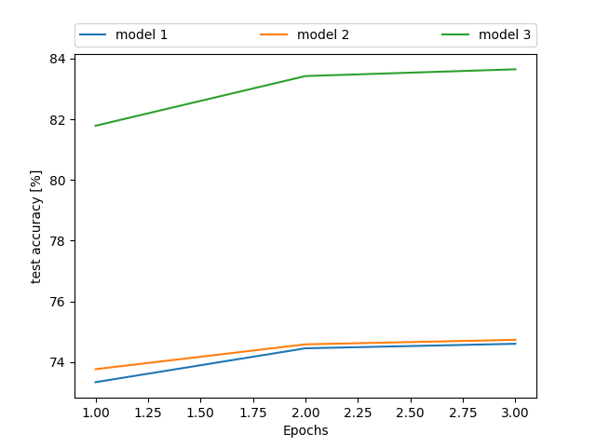

with the bi-grams we get ~84%, and the other models is around 74%.

for the bonus:
here is the heatmap of the bi-grams:
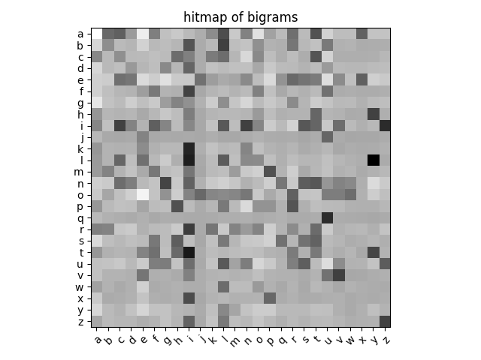

* if you want to get the bi-gram and the model’s accuracy, please run the python code:
ploting.py
(I add all the necessary files compressed – with pickle to the submit, again -you only needed to run the code.)

